- Title Page:
- Project Title: Cloud Log Analysis for Intrusion and Attack Detection
- Name: Shruti Saroj
- College Name: Rizvi College Of Engineering
- Department (Computer Engineering)
- Course (Cloud Computing)

- Abstract:
This project presents a cloud-based log analysis system designed to detect intrusion and suspicious activities in web servers. A web server is deployed on AWS EC2 and generates access logs whenever users interact with the server. These logs are stored and analyzed using a Python script to identify abnormal request patterns such as repeated access attempts or excessive requests from the same IP address. The system helps detect potential attacks like brute-force login attempts and DDoS attacks. By automating log analysis, the system improves security monitoring and allows administrators to respond quickly to threats.

- Introduction:
Cloud computing is a technology that allows users to access computing resources such as servers, storage, and applications over the internet instead of local machines. It provides scalable infrastructure that can handle large amounts of data and user requests efficiently.
As cloud systems receive large volumes of traffic, security monitoring becomes important. Attackers may attempt unauthorized access, brute-force attacks, or other malicious activities that can affect system performance and data security. One effective way to monitor security in cloud environments is through log analysis.
Log analysis refers to the process of collecting, examining, and interpreting log files generated by servers and applications. These logs contain important information such as user IP addresses, request times, accessed resources, and response status codes. By analyzing these logs, administrators can identify abnormal behaviour, detect potential threats, and take necessary actions to prevent security breaches.

- Problem Statement:
Cloud-based applications receive a large number of user requests, making it difficult to manually monitor system activity and detect potential security threats.
Attackers may attempt unauthorized access, brute-force attacks, or generate excessive traffic that can affect system performance and security. Therefore, an automated system is required to analyze server logs and detect suspicious activities in cloud environments.

- Technologies Used:
• AWS EC2 – Used to deploy the cloud server and host the application.
• Apache Web Server – Generates server access logs based on user requests.
• AWS S3 – Used for storing log files in the cloud.
• Python – Used to analyze log files and detect suspicious activities.
• Linux (Ubuntu) – Provides the environment for running the server and scripts.

- System Architecture:
Users
↓
AWS EC2 (Apache Web Server)
↓
Server Logs Generated (access.log)
↓
Logs Stored in AWS S3
↓
Python Log Analyzer
↓
Intrusion Detection Report

- Implementation Steps:
- Launch an EC2 instance on AWS and configure security groups to allow HTTP and SSH traffic.
- Install Apache Web Server on the EC2 instance to host the web application and generate access logs.
- Access the server through a browser to generate user request logs.
- Store the generated log files in AWS S3 for analysis and storage.
- Develop a Python script to analyze the log file and count requests from different IP addresses.
- Detect suspicious activities such as repeated requests from the same IP address.
- Display the intrusion detection report showing potential malicious traffic.

- Results:
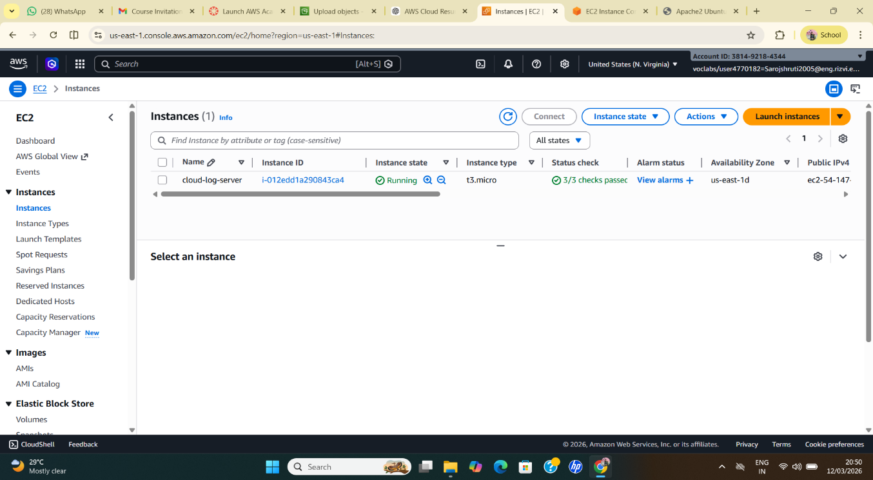

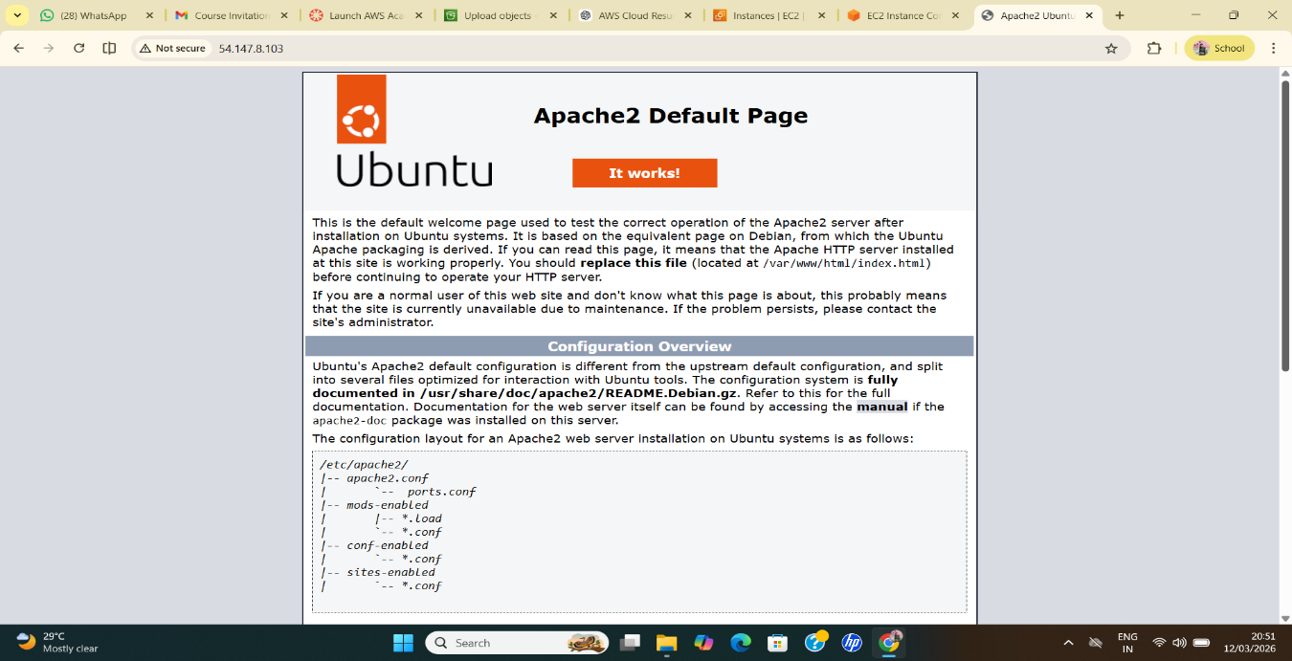

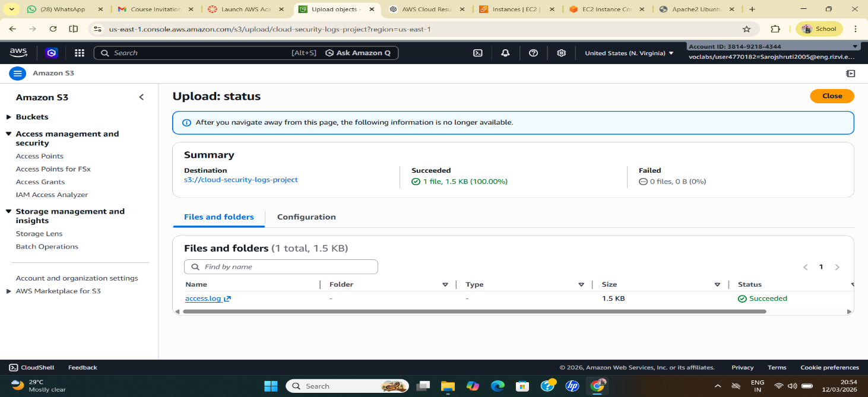
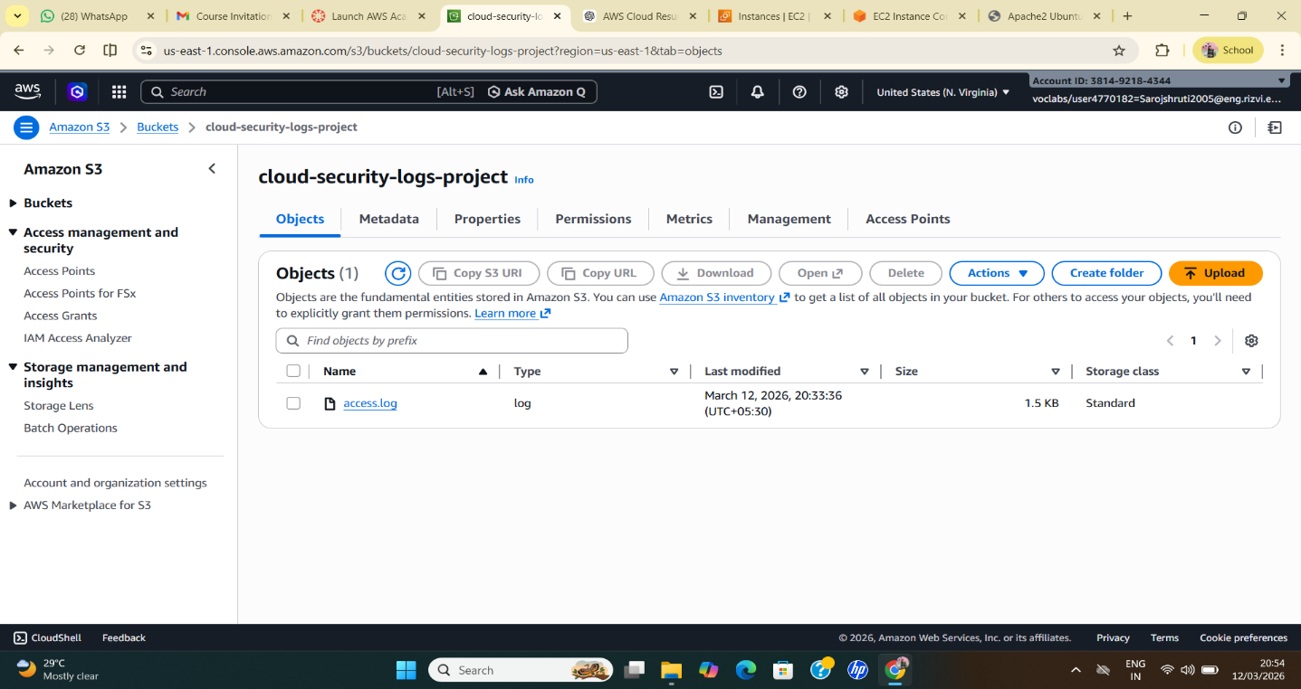

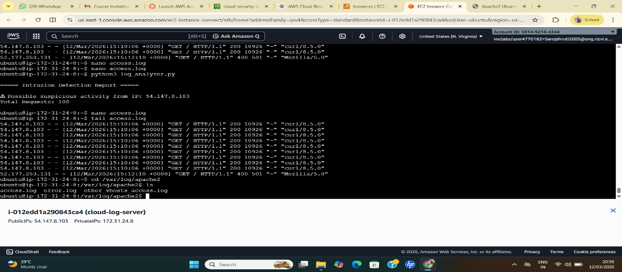

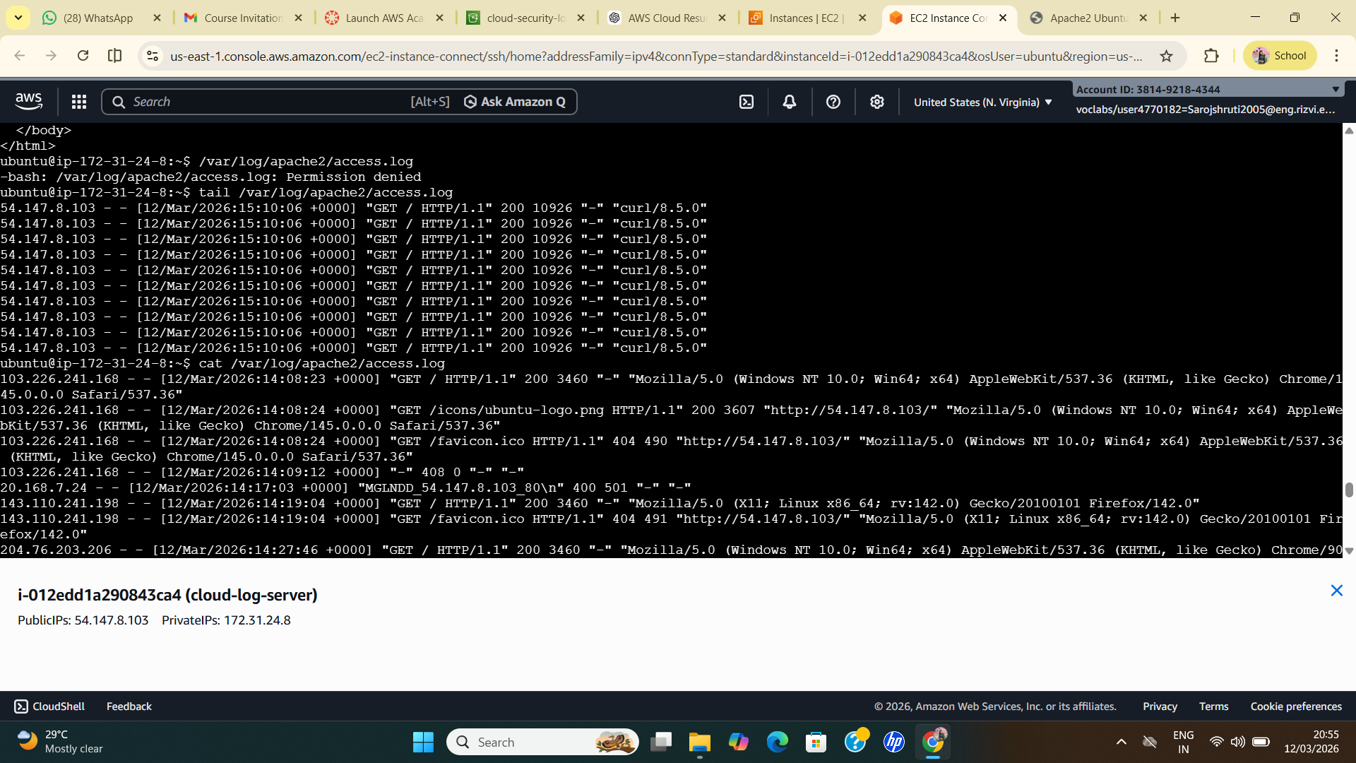
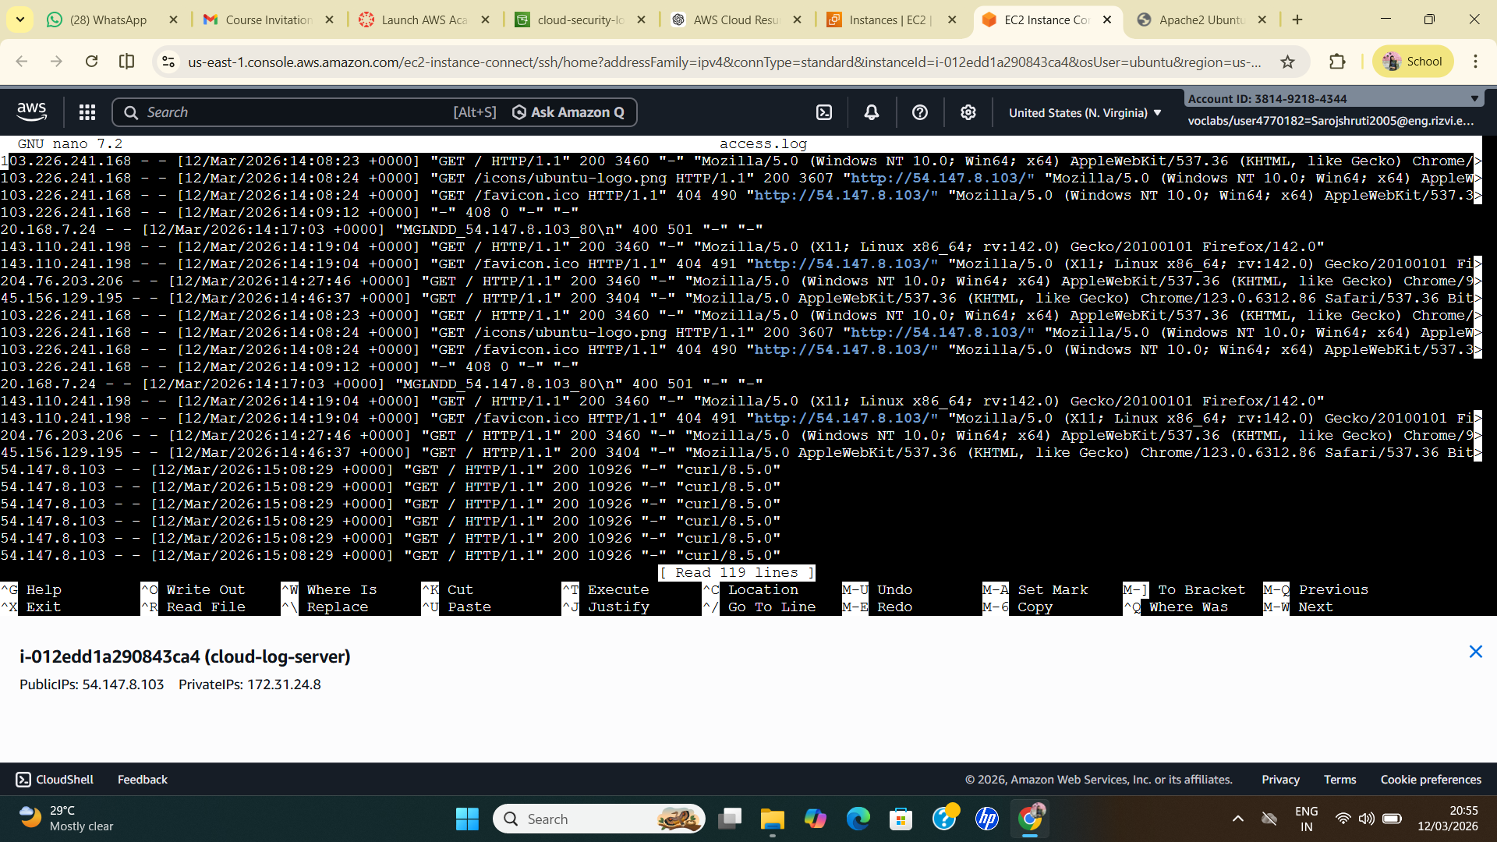

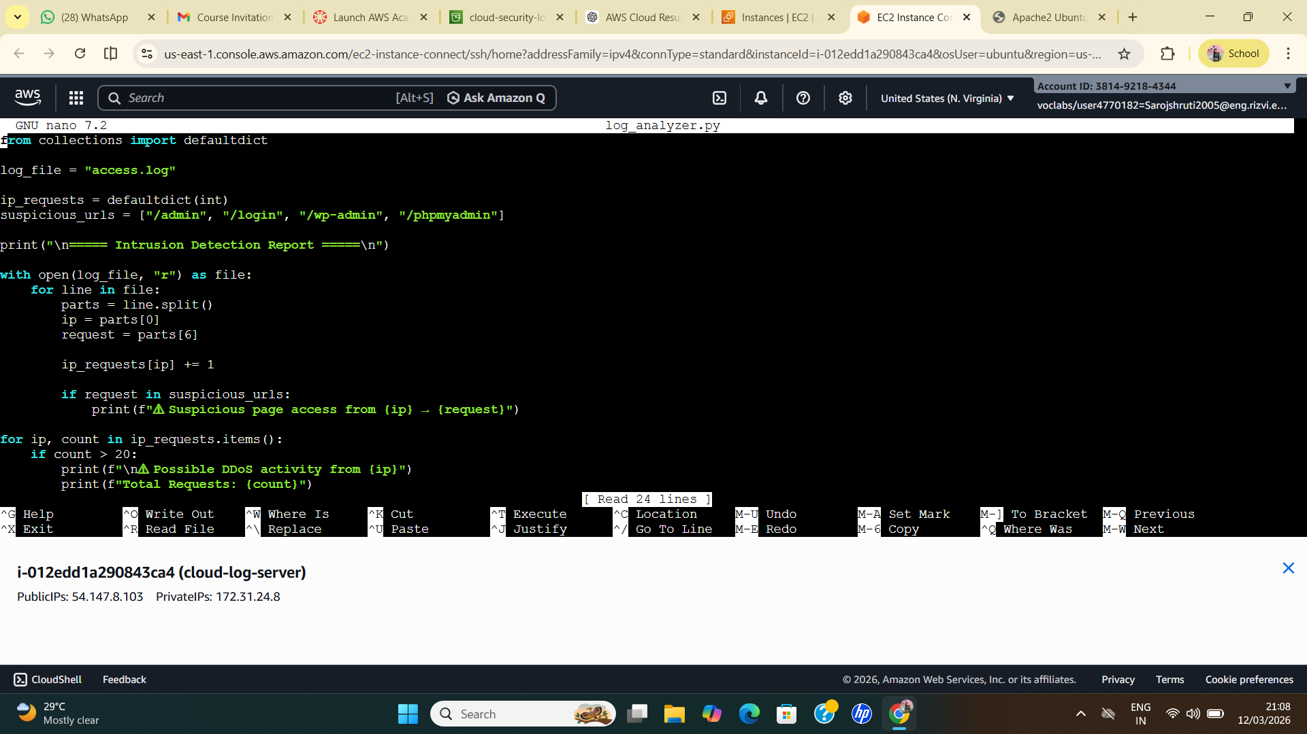
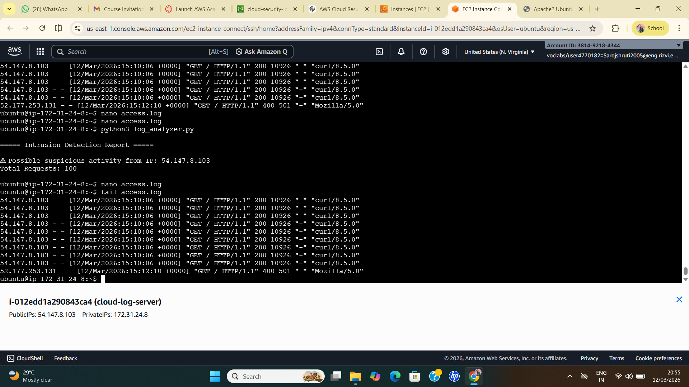

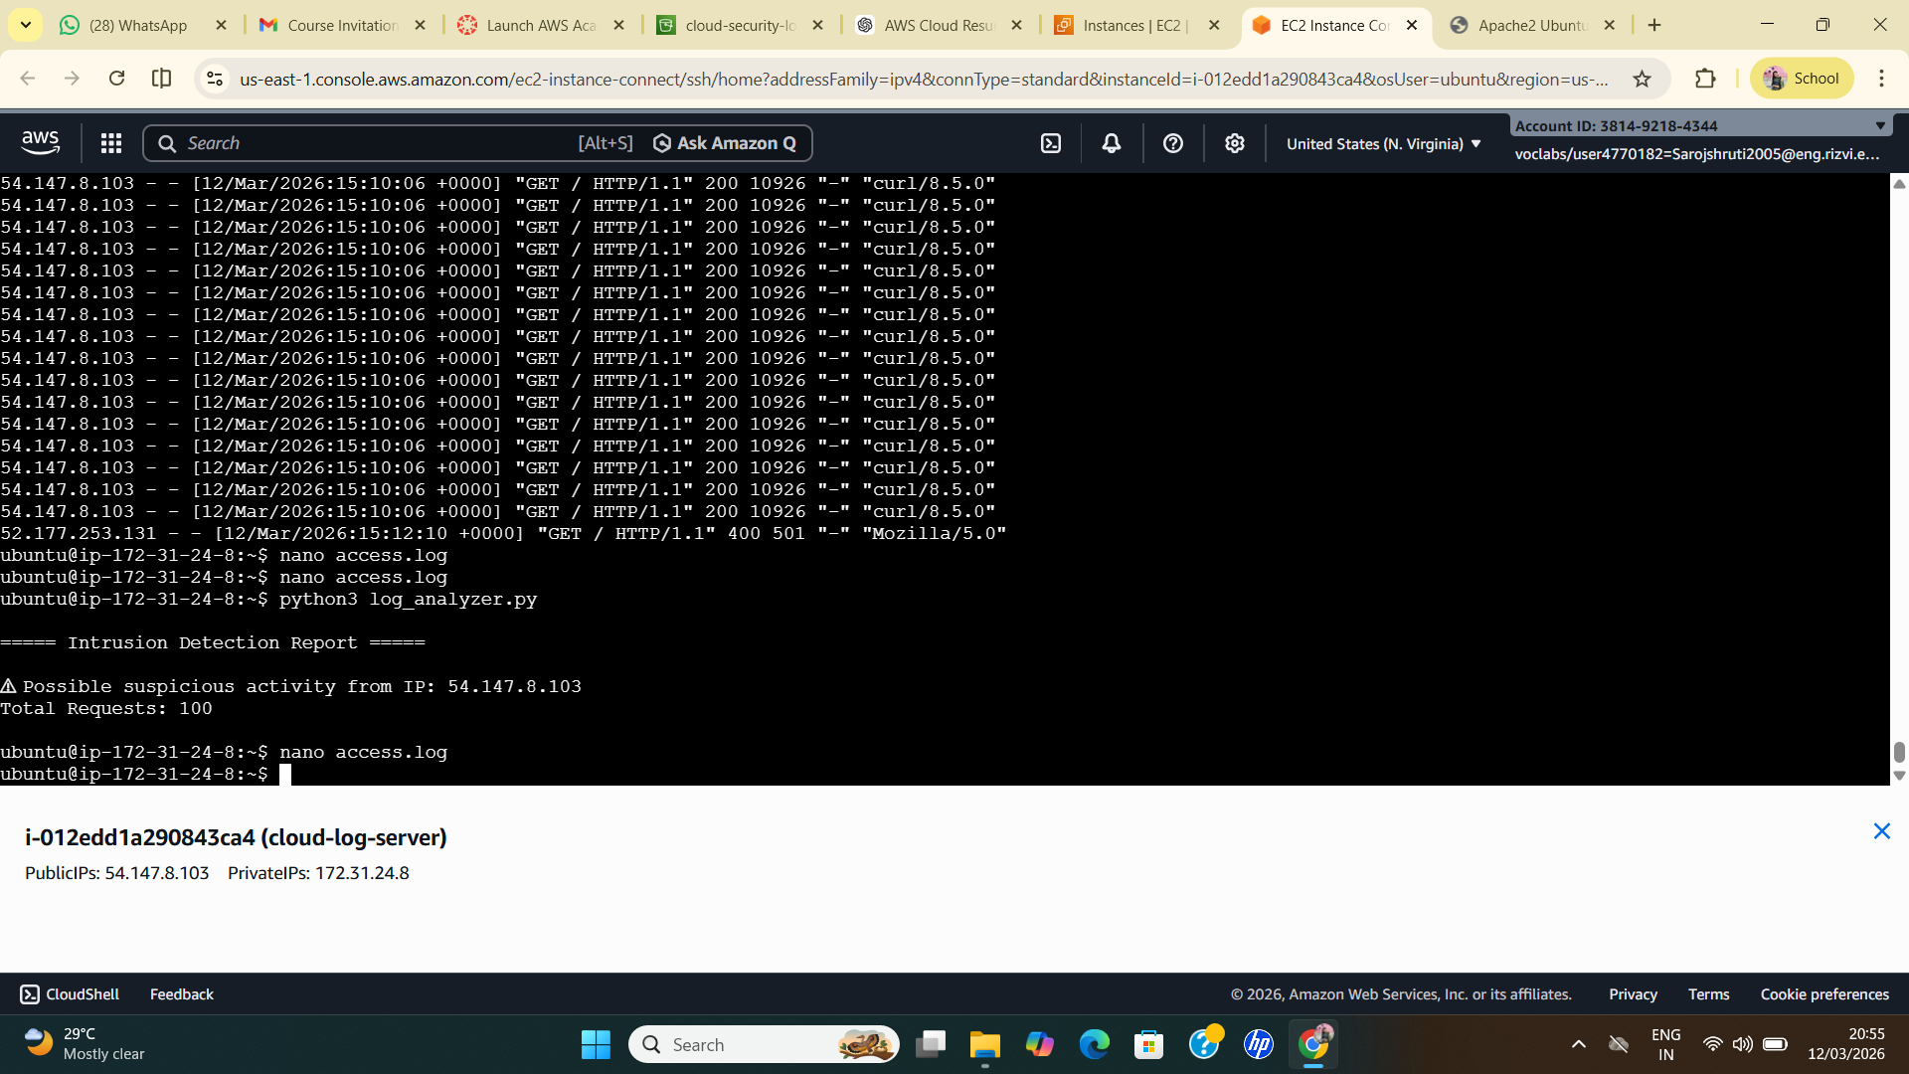

- Advantages:
• Provides automated monitoring of server activities in cloud environments.
• Helps detect suspicious traffic and possible attacks such as excessive requests from the same IP address.
• Improves system security by identifying abnormal user behaviour early.
• Uses cloud infrastructure, which makes the system scalable and efficient.
• Helps administrators analyze logs quickly without manual inspection.

- Conclusion:
The project demonstrates how server logs generated in a cloud environment can be analyzed to detect suspicious activities. By deploying a web server on AWS EC2 and analyzing the generated logs using a Python script, the system is able to identify abnormal traffic patterns from specific IP addresses. This approach helps improve security monitoring and provides an effective way to detect potential cyber threats in cloud-based systems.

- Future Scope:
- Integrate real-time monitoring using cloud services such as log monitoring tools.
- Implement machine learning models to detect more complex attack patterns.
- Add automatic alert notifications for administrators when suspicious activity is detected.
- Integrate automatic IP blocking mechanisms to prevent repeated attacks.
- Expand the system to analyze logs from multiple servers and applications.

